I can find fractions of amounts
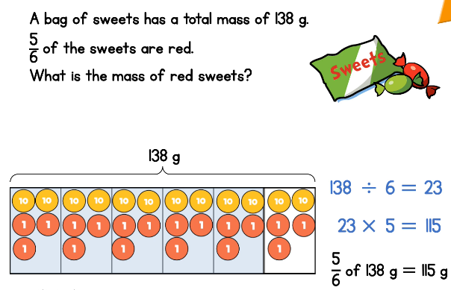
Use this strategy to solve the problems below.
A bag of sweets has a total mass of 132g.  $\frac{5}{6}$ of the sweets are red.  What is the mass of the red sweets? | The mass of the red sweets is ______g
A bag of sweets has a total mass of 132g.  $\frac{2}{6}$ of the sweets are red.  What is the mass of the red sweets? | The mass of the red sweets is ______g
A bag of sweets has a total mass of 132g.  $\frac{2}{4}$ of the sweets are red.  What is the mass of the red sweets? | The mass of the red sweets is ______g
A bag of sweets has a total mass of 132g.  $\frac{3}{4}$ of the sweets are red.  What is the mass of the red sweets? | The mass of the red sweets is ______g

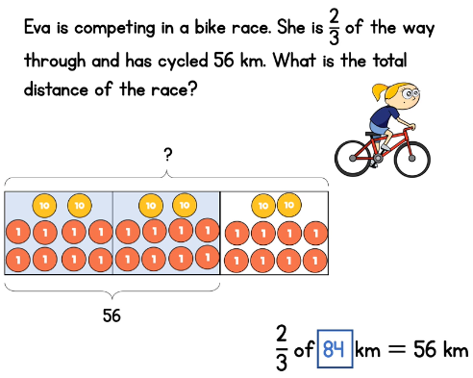

Use this strategy from the video clip to solve these problems.

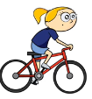  Eva is competing in a bike race. She is $\frac{2}{3}$ of the way through and has cycled 44km. What is the total distance of the race? | 44km  The total distance of the race is ______km
Eva is competing in a bike race. She is $\frac{2}{3}$ of the way through and has cycled 48km. What is the total distance of the race? | 48km  The total distance of the race is ______km
Eva is competing in a bike race. She is $\frac{2}{3}$ of the way through and has cycled 52km. What is the total distance of the race? | __km  The total distance of the race is ______km
Eva is competing in a bike race. She is $\frac{2}{3}$ of the way through and has cycled 60km. What is the total distance of the race? | __km  The total distance of the race is ______km

